# Lab: Multidimensional Lists

Problems for in-class lab for the [Python Advanced Course @SoftUni](https://softuni.bg/courses/python-advanced).

Submit your solutions in the SoftUni judge system at <https://judge.softuni.bg/Contests/1834>.

## Sum Matrix Elements

Write a program that **reads a matrix** from the console and prints:

* The sum of all **matrix elements**
* The **matrix itself**

On the first line, you will receive the matrix sizes in format **"{rows}, {columns}".** On the next **rows**, you will get elements for each column separated with a **", "**.

### Examples

|  |  |
| --- | --- |
| **Input** | **Output** |
| 3, 6  7, 1, 3, 3, 2, 1 1, 3, 9, 8, 5, 6 4, 6, 7, 9, 1, 0 | 76  [[7, 1, 3, 3, 2, 1], [1, 3, 9, 8, 5, 6], [4, 6, 7, 9, 1, 0]] |

## Sum Matrix Columns

Write a program that **reads a matrix** from the console and prints the **sum for each column** on separate lines. On the first line, you will get matrix sizes in format **"{rows}, {columns}"**. On the next **rows**, you will get elements for each column separated with a single space.

### Examples

|  |  |
| --- | --- |
| **Input** | **Output** |
| 3, 6  7 1 3 3 2 1  1 3 9 8 5 6  4 6 7 9 1 0 | 12  10  19  20  8  7 |
| 3, 3  1 2 3  4 5 6  7 8 9 | 12  15  18 |

### Hints

* **Read** matrix **sizes**.
* On the next row lines, **read** the **columns**.
* **Traverse** the matrix and **sum** all elements in **each** column.
* Print the **sum** and **continue** with the other columns.

## Primary Diagonal

Write a program that finds the **sum of matrix primary diagonal**. On the **first line**, you will receive an integer **N** – the size of the square matrix. The next N **lines** holds the values for **every row** – N numbers, separated by a single space

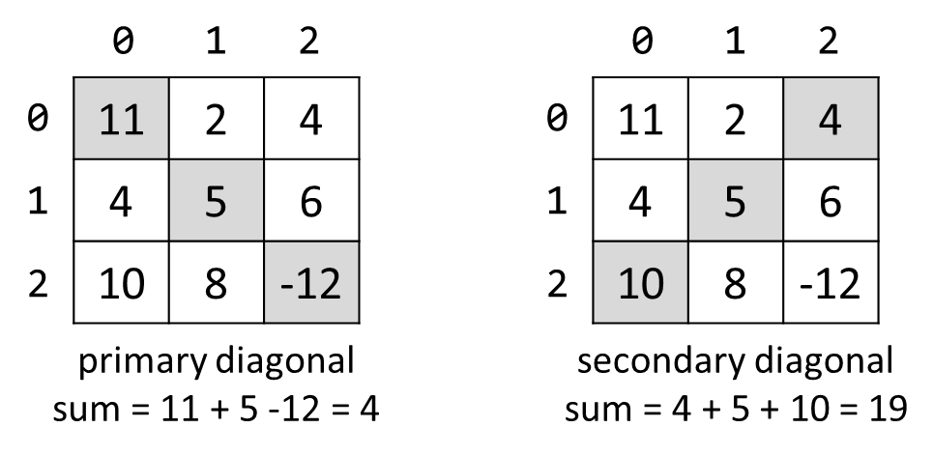

### Examples

|  |  |
| --- | --- |
| **Input** | **Output** |
| 3  11 2 4  4 5 6  10 8 -12 | 4 |
| 3  1 2 3  4 5 6  7 8 9 | 15 |

## Symbol in Matrix

Write a program that reads a number - **N**, representing the **rows** and **columns** of a **matrix**. On the next **N** lines, you will receive rows of the matrix. Each row consists of ASCII characters. After that, you will receive a symbol. Find the **first occurrence** of that symbol in the matrix and print **its position** in the format: "({row}, {col})". You shouldstart searching from the **top left.** If there is no such symbol print an error message "{symbol} does not occur in the matrix"

### Examples

|  |  |
| --- | --- |
| **Input** | **Output** |
| 3  ABC  DEF  X!@  ! | (2, 1) |
| 4  asdd  xczc  qwee  qefw  4 | 4 does not occur in the matrix |

## Square with Maximum Sum

Write a program that **reads a matrix** from the console. On first line you will get matrix sizes in format **"{rows}, {columns}".** On the next **rows**, you will get elements for each column separated with a **", "**. Find the **2x2 top-left** **submatrix** with **biggest sum** of its values. Print the matrix and the sum of its elements as shown in the examples.

### Examples

|  |  |
| --- | --- |
| **Input** | **Output** |
| 3, 6  7, 1, 3, 3, 2, 1 1, 3, 9, 8, 5, 6 4, 6, 7, 9, 1, 0 | 9 8  7 9  33 |
| 2, 4  10, 11, 12, 13  14, 15, 16, 17 | 12 13  16 17  58 |

### Hints

* Be aware of **IndexError**
* If you find more than one max square, print the **top-left one**